Chapter 4, Problem 78.

Use PSpice to solve Prob. 4.52.

Chapter 4, Problem 52.

For the transistor model in Fig. 4.111, obtain the Thevenin equivalent at terminals a-b.

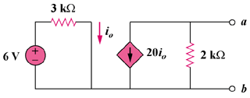

Figure 4.111
For Prob. 4.78.

